Gallstones & Laparoscopic Cholecystectomy

Most adults with gallstones do not have symptoms. Eighty percent of people with gallstones go 20 years without symptoms.

Gallstones are more common in people who:
- Have a family history of gallstones
- Are overweight
- Have sickle cell disease
- Are pregnant
- Lose weight rapidly
- Use oestrogen to manage menopause
Gallbladder pain or biliary colic is usually temporary. It starts in the middle or the right side of the abdomen and can last from 30 minutes to 24 hours. The pain may occur after eating a fatty meal.
- Acute cholecystitis pain lasts longer than 6 hours, and there is abdominal tenderness and fever.
- Pain on the right side of the abdomen can also be from ulcers, liver problems, and heart pain.
- Standard treatment of acute cholecystitis is intravenous (IV) fluids, pain medication, and cholecystectomy.

Jaundice (yellowing of the skin) may occur if gallstones are in the common bile duct.
Gallstone Pancreatitis is caused by stones moving into and blocking the common bile duct, the pancreatic duct, or both.
Cholecystitis in Children
Four of 100 gallbladder removals are done in children.13 Almost 70% of children with gallstones do have symptoms. Symptoms in children include abdominal pain, nausea, vomiting, jaundice, fatty food intolerance, and fever.
Common Tests following History and Physical Exam may include:
● Blood tests, including complete blood count ● Liver function tests
● Coagulation profile
● Abdominal ultrasound is the most common study for gallbladder disease.1-2 You may be asked not to eat for 8 hours before the test.
● Hepatobiliary iminodiacetic acid scan (HIDA scan)
● Endoscopic retrograde cholangiopancreatography (ERCP)
● Magnetic resonance cholangiopancreatography (MRCP)

Treatment options:
Watchful waiting is recommended if you have gallstones but do not have symptoms.
About 1 in 5 newly diagnosed patients with acute cholecystitis who do not have surgery readmit to the emergency department within about 12 weeks. ● Increase your exercise. Exercising 2 to 3 hours a week reduces the risk of gallstones.11-12
A low-fat diet: Eat more fruit and vegetables, eat less of foods high in sugars and carbohydrates like donuts, pastry, and white bread.
Surgical Treatment : A cholecystectomy, or removal of the gallbladder, is the recommended operation for gallbladder pain from gallstones.
Laparoscopic Cholecystectomy
This technique is the most common for simple cholecystectomy. The surgeon will make several small incisions in the abdomen. Ports (hollow tubes) are inserted into the openings. Surgical tools and a lighted camera are placed into the ports. The abdomen is inflated with carbon dioxide gas to make it easier to see the internal organs. The gallbladder is removed, and the port openings are closed with sutures, surgical clips, or glue. Your surgeon may start with a laparoscopic technique and need to change (convert) to an open laparotomy technique. The procedure takes about 1 to 2 hours.
Open Cholecystectomy
The surgeon makes an incision approximately 6 inches long in the upper right side of the abdomen and cuts through the fat and muscle to the gallbladder. The gallbladder
is removed, and any ducts are clamped off. The site is stapled or sutured closed. A small drain may be placed going from the inside to the outside of the abdomen. The drain is usually removed in the hospital. The procedure takes about 1 to 2 hours.
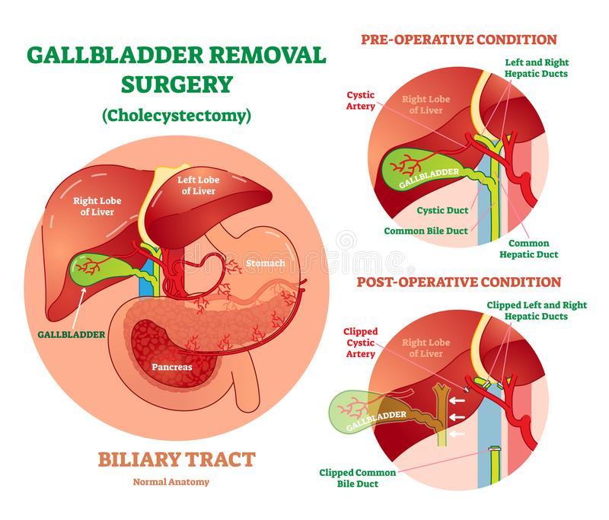

Risks of this Procedure
Cholecystectomy
Risks Based on the American College of Surgeons Risk Calculator
Open Cholecystectomy and Laparoscopic Cholecystectomy from the ACS Risk Calculator – August 2, 2015
Risks | Percent for Average Patient | Keeping You Informed
Pneumonia: Infection in the lungs | Open 1.7% Laparoscopic 0.2% | You can decrease your risk by rinsing with mouthwash the morning of your operation (to decrease mouth bacteria), quitting smoking before your operation, and getting up often to walk post-operatively.
Heart complication: Heart attack or sudden stopping of the heart | Open 0.7% Laparoscopic 0.1% | Problems with your heart or lungs can be affected by general anaesthesia. Your anaesthetist will take your history and suggest the best option for you.
Wound infection | Open 7.6% Laparoscopic 1% | Antibiotics are not routinely given except for high-risk patients. You should wash your abdomen with soap such the night before the operation.
Urinary tract infection: Infection of the bladder or kidneys | Open 1.5% Laparoscopic 0.5% | A Foley catheter is placed during surgery to drain the urine. Let your surgical team know if you have trouble urinating after the tube is removed—this is more common in older men or if an epidural is used for pain.
Blood clot: A blood clot in the legs can travel to the lung | Open 1% Laparoscopic 0.2% | Longer surgery and bed rest increase the risk. Walking 5 times/day and wearing support stockings reduce the risk.
Renal (kidney) failure: Kidneys  no longer function in making urine and/or cleaning the blood of toxins | Open 0.9% Laparoscopic 0.1% | Pre-existing renal problems, Type 1 diabetes, being over 65 years old, and other medications may increase the risk.
Return to theatre | Open 3.3 % Laparoscopic 0.8% | Bile leakage or a retained stone may cause a return to surgery. Your surgical team is prepared to reduce all risks of return to surgery.1
Death | Open 0.8% Laparoscopic 0.1% | Your surgical team will review for possible complications and be prepared to decrease all risks.
Delayed discharge or discharge rehab. | Open 5.4% Laparoscopic 0.6% | Pre-existing health conditions can increase this risk.
Bile Duct Injury/Leakage*1,16 | 0.5% | Injury can become apparent between 1 week to 6 months after the operation from fever, pain, jaundice, or bile leakage from the incision. Further testing and surgery may be needed.1,17
Retained common bile duct stone*1 | 4% to 40% | A gallstone may pass after surgery and block the bile from draining. The stone should be removed because of an increased risk of biliary obstruction or inflammation of the pancreas or bile duct.1
Pregnancy Complications, premature labour and foetal loss* | Foetal loss 4% (uncomplicated removal) up to 60% if pancreatitis | Most pregnant women with gallstones will have no symptoms during pregnancy. If you have biliary disease or pancreatitis, gallbladder removal will be offered to reduce maternal complications.18
1% means that 1 of 100 people will have this complication *Results from the last 10 years of literature
The ACS Surgical Risk Calculator estimates the risk of an unfavorable outcome. Data is from a large number of patients who had a surgical procedure similar to this one. If you are healthy with no health problems, your risks may be below average. If you smoke, are obese, or have other health conditions, then your risk may be higher. This information is not intended to replace the advice of a doctor or health care provider. To check your risks, go to the ACS Risk Calculator at http://riskcalculator.facs.org.

Preparing for Your Operation
Complications are generally less common after planned rather than emergency procedures.
Medication
Bring a list of all of the medications and vitamins that you are taking, including blood thinners, aspirin, or NSAIDS, and inform your surgical team. Some medications can affect your recovery and response to anaesthesia and may have to be adjusted before and after surgery. Most often, you will
take your morning medication with a sip of water.
Anaesthesia
Let pre-assessment or anaesthetist know if you have allergies, neurologic disease (epilepsy, stroke), heart disease, stomach problems, lung disease (asthma, emphysema), endocrine disease (diabetes, thyroid conditions), or loose teeth; if you smoke, drink alcohol, use drugs, or take any herbs or vitamins; or if you have a history of nausea and vomiting with anaesthesia.
If you smoke you should plan to quit. Quitting before your surgery can decrease your rate of respiratory and wound complications and increase your chances of staying smoke-free for life.
Length of Stay
If you have a laparoscopic cholecystectomy, you will usually go home the same day. You may stay overnight or longer if you had an open removal of the gallbladder, a laparoscopic repair with a longer anaesthetic time, post-anaesthetic issues such as severe nausea and vomiting, or you are unable to pass urine.
The Day of Your Operation
Do not eat for 6 hours or drink anything but clear liquids (ie non-milky water based) for at least 2 hours before the operation. Shower and clean your abdomen and groin area with a mild antibacterial soap. Brush your teeth and rinse your mouth out with mouthwash. Do not shave the surgical site; your surgical team will clip the hair nearest the incision site.
An identification (ID) bracelet and allergy bracelet with your name and hospital/
clinic number will be placed on your wrist. These should be checked by all health team members before they perform any procedures or give you medication.
In the anaesthetic room - an intravenous line (IV) will be started
to give your fluids and medication. For general anaesthesia, you will be asleep
and pain-free. A tube will be placed down your mouth/throat to help you breathe during the operation.

After Your Operation
You will be moved to a recovery room where your heart rate, breathing rate, oxygen saturation, blood pressure, and urine output will be closely watched. Be sure that all visitors wash their hands.
Preventing Pneumonia and Blood Clots
Movement and deep breathing after your operation can help prevent postoperative complications such as blood clots, fluid in your lungs, and pneumonia. Every hour, take 5 to 10 deep breaths and hold each breath for 3 to 5 seconds.
When you have an operation, you are at risk of getting blood clots because of not moving during anaesthesia. The longer and more complicated your surgery, the greater the risk. This risk is decreased by getting up and walking 5 to 6 times per day, wearing special support stockings or compression boots on your legs, and, for high-risk patients, taking a medication that thins your blood.
Your Recovery and Discharge
Thinking Clearly
After a general anaesthetic is given or if you are taking narcotic pain medication, it may cause you to feel different for 2 or 3 days, have difficulty with memory, or feel more fatigued. You should not drive, drink alcohol, or make any big decisions for at least 2 days.
Nutrition
When you wake up from the anesthesia, you will be able to drink small amounts of liquid. If you do not feel sick, you can begin eating regular foods. Continue to drink about 8 to 10 glasses of water per day. Eat a high-fibre diet so you don’t strain while having a bowel movement.
Activity
Slowly increase your activity. Be sure to get up and walk every hour or so to prevent blood clot formation. Patients usually take 1 to 3 weeks to return comfortably to normal activity. You may go home the same day aftera laparoscopic repair. If you have other health conditions or complications such as nausea, vomiting, bleeding, or difficulty passing urine, you may stay longer. Persons sexually active before the operation reported being able to return to sexual activity in 14 days (average).
Work
You may usually return to work 1-2 week after laparoscopic or open repair, as long as you don’t do any heavy lifting and feel well. Discuss the timing with your surgeon. Recovery times vary from person to person and particularly if you have been unwell prior to the operation recovery can be up to 4-6 weeks for some.
Steri-Strips®
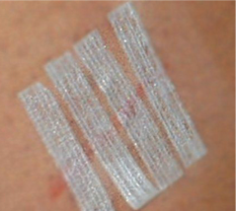
Always wash your hands before and after touching near your incision site. Do not soak in a bathtub until your stitches, Steri-Strips®, or staples are removed.
You may take a shower after the second postoperative day unless you are told not to. Change the bandages if they come of or become soaked. A small amount of drainage from the incision is normal. If the dressing is soaked with blood, contact the hospital.
If you have Steri-Strips in place, they will fall off or can be peeled off in 7 to 10 days. If you have a glue-like covering over the incision, just let the glue to flake off on its own. Avoid wearing tight or rough clothing. It may rub your incisions and make it harder for them to heal.
Your scars will heal in about 4 to 6 weeks and will become softer and continue to fade over the next year. Avoid direct exposure to strong sunlight for a year after surgery as this may increase pigmentation.
Bowel Movements
Anaesthesia, decreased activity, and pain medication (narcotics) can contribute to constipation. Avoid straining with bowel movements by increasing the fiber in your diet with high-fibre foods or over-the-counter medicines (Bisacodyl, lactulose or Senna).
Be sure you are drinking 8 to 10 glasses of fluid each day.
Pain
The amount of pain is different for each person. The new medicine you will need after your operation is for pain control, and you will be advised how much you should take. You can use throat lozenges if you have sore throat from the tube placed in your throat during your anaesthesia.
Do not lift items heavier than 10 pounds/4-5 kgs or participate in strenuous activity for at least 4 to 6 weeks.

When to Contact the Hospital:
Contact the hospital if you have:
- Pain that will not go away
- Pain that gets worse
- A fever of more than 101°F or 38.3°C
- Continuous vomiting
- Swelling, redness, bleeding, or bad-smelling drainage from your wound site
- Strong or continuous abdominal pain or swelling of your abdomen
- No bowel movement 3 days after the operation
Bob Soin FRCS MD August 2018
This leaflet is based on the ACS cholecystectomy leaflet and is acknowledged with thanks.

